**Enable transcript**

To enable transcription using GPO just create an object and set the following:

User or Computer config \Policies\Administrative\Windows Components\Windows Powershell

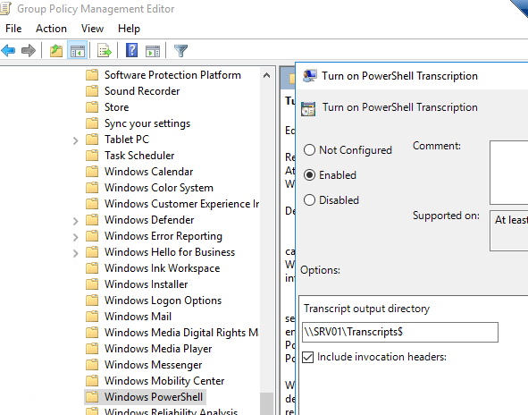

Create the folder and set permissions: <https://blogs.msdn.microsoft.com/powershell/2015/06/09/powershell-the-blue-team/>

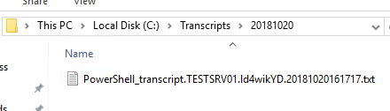

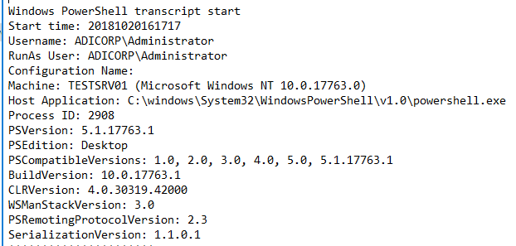

**Enable script block logging**

User or Computer config \Policies\Administrative\Windows Components\Windows Powershell

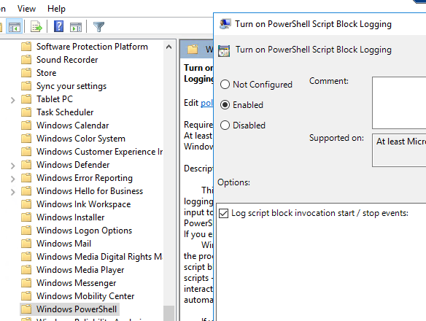

Get-WinEvent -LogName Microsoft-Windows-Powershell/Operational | Where-Object {$_.id -eq 4104}

